
TwitterVane

Administrators
Guide

21 February 2013
Contents


Introduction 3
About TwitterVane 3
About this document 3
Where to find more information 3
System Overview 4
Purpose and scope 4
How does it work? 4
TweetAnalyser 6
Jobs 6
Job Results 7
Tasks 7
TweetStreamAgent 8
Twitter Stream 8
Application Configuration 10

Introduction

About TwitterVane
TwitterVane is a tool for leveraging the power of the crowd to select websites for web archiving. It enables curators to define web collections and identify trending Tweets and associated URLs that are relevant to those collections.

About this document
This document is the TwitterVane Administrators Guide. It describes how to control, monitor and maintain Tweet Stream and Tweet processing for the TwitterVane web application.
For installation, setup and configuration information, refer to the “TwitterVane System Installation Guide.doc”.

Where to find more information
The public resources for TwitterVane, including the source code, binaries and documentation, are available through the TwitterVane Open Source GitHub project:

https://github.com/ukwa/twittervane

System Overview

Purpose and scope
The application has been designed to stream Tweets directly from Twitter and store them for analysis. The analysis consists of expanding any shortened URLs associated with the Tweets using the Bitly expander service and associates the Tweets with the Web Collections that have been defined.

How does it work?
TwitterVane is divided into three major components

TweetView

TweetView is the curator web interface where users define the collections and search terms that will be used to collect Tweets. A series of reports is also provided to identify popular Tweets and top URLs by collection.

TweetStreamAgent

TweetStreamAgent streams Tweets directly from Twitter and stores them in the TwitterVane database for further analysis. It uses the search terms that have been defined by curators through TweetView to filter the Tweet stream. This is a management web interface that enables administrators to control and configure the Tweet stream.

TweetAnalyser

TweetAnalyser runs periodically, after a specific number of Tweets have been received from the Tweet stream, and expands any shortened URLs using Bitly. Any Tweet URLs are then resolved to the web collection using the collection’s search terms.

TwitterVane Application
Twitter Streaming API
TweetView
curator
TweetAnalyser
admin
Process every 100 Tweets (Spring RMI)
JPA + Hibernate Persistence Provider
TweetStreamAgent

Database
Bitly expander service
Expand 10 most popular URLs per 100 Tweets
Manage Tweet Stream
Manage Analysis Data Stream
Manage Web Collections/Run Reports
Store Tweet
& URLs
TwitterVane Component Diagram

TweetAnalyser

The main page that controls the TweetAnalyser is pictured below:

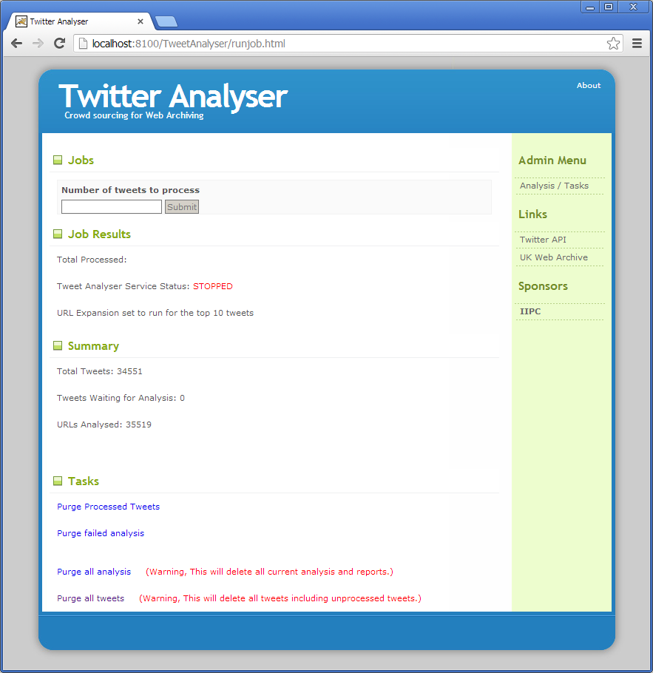

Jobs

The Jobs section enables administrators to input the number of Tweets to be analysed. Enter a positive number in the Number of tweets to process field and click Submit to launch the processing. If the field is left blank, the TweetAnalyser will analyse all unprocessed Tweets in the database.

Job Results
This section displays the total number of Tweets that have been processed in the last processing run.

To preserve memory, the Tweets are processed in batches so that only a specified number of Tweets are loaded into memory at any given point in time. This number is specified in the configuration for the TweetAnalyser (refer to the “TwitterVane System Installation Guide.doc”).

The Total Tweets figure displays the total number of Tweets in the database when the TweetAnalyser processing run was started. This figure is based on summary information gathered during the analysis. The information is collected to remove the need to perform expensive queries during the processing run.

The Tweets Waiting for Analysis figure displays the number of unprocessed Tweets.

The URLs Analysed figure displays the total number of URLs that have been analysed for all processed Tweets.

Tasks
The Tasks section enables the administrator to perform limited housekeeping operations on Tweet and URL data.

Purge Processed Tweets
WARNING: This action will delete all Tweets and associated URLs that have been processed.

Purge failed analysis
WARNING: This action deletes all URLs that encountered an error during analysis. It will not delete any Tweets from the database.

Purge all analysis
WARNING: This action deletes all URLs within the database. It will not delete any Tweets.

Purge all tweets
WARNING: This action deletes all Tweets and associated URLs from the database.

TweetStreamAgent

The main TweetStreamAgent control page is pictured below:

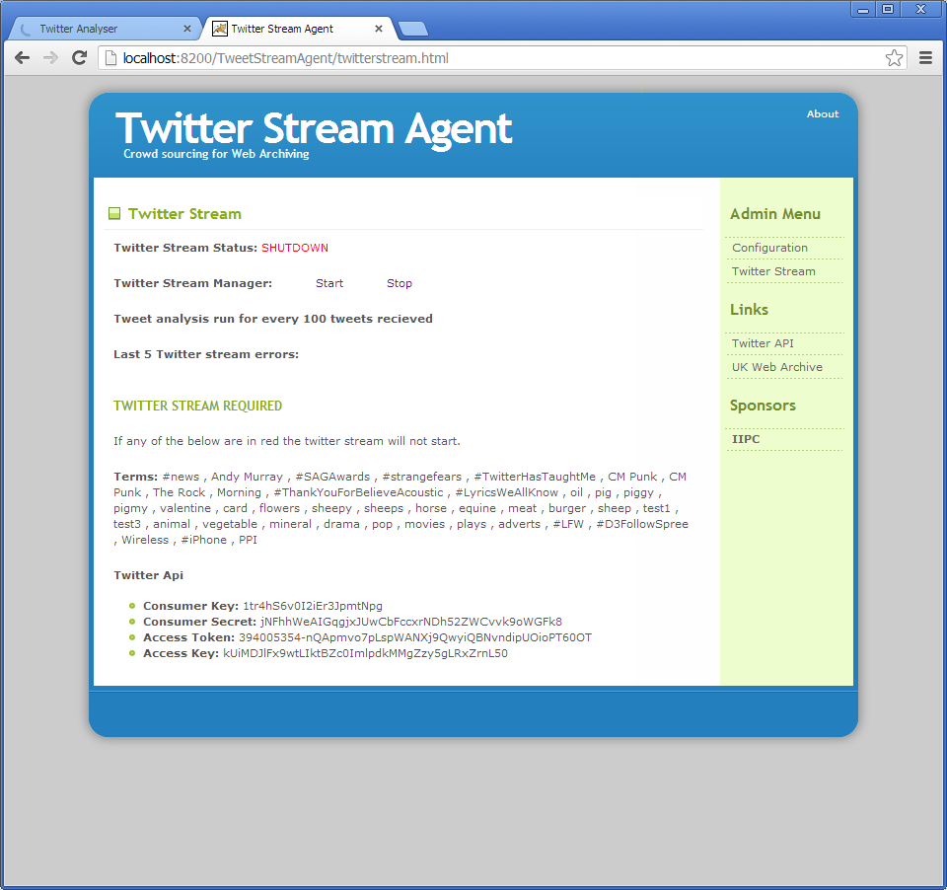

Twitter Stream
The Twitter Stream section enables the administrator to start and stop the Tweet stream from Twitter.

The Twitter Stream Status displays the current status of the Twitter Stream Agent. The status’ are:

RUNNING
- the Twitter Stream consumer and Twitter4J Async Dispatcher threads are running

SHUTDOWN
- the Twitter Stream consumer and Twitter4J Async
Dispatcher threads have been shutdown and cleanup has been performed
Start
This action will start the Tweet Stream daemon and transition the status from SHUTDOWN to RUNNING.

Stop
This action will stop the Tweet Stream daemon and transition the status from RUNNING to SHUTDOWN.

Note that TweetStreamAgent should be stopped prior to the deployment of the TweetAnalyser component.

This section also displays the currently configured Tweet analysis trigger value (refer to the “TwitterVane System Installation Guide.doc” for information on this setting).

A log of the last 5 errors encountered by the TweetStreamAgent is also displayed in this section. An example of the errors displayed when Twitter limits the number of stream connections is displayed below:

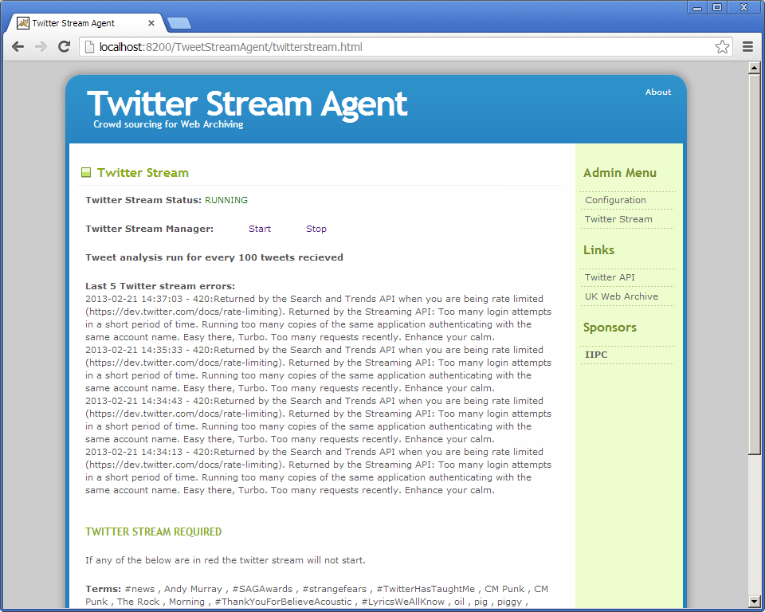

At the end of the section, the currently loaded search terms are displayed for all web collections. These search terms are reloaded after the analysis is run so that any search term changes are incorporated into the filtered stream from Twitter.

Finally, the current Twitter API details are displayed. These are credentials and application keys that are registered with Twitter and Bitly and are used for Tweet stream access and URL expansion (as detailed in the next section).

Application Configuration

The Application Configuration page accessed by clicking the Configuration link in the right hand navigation menu:

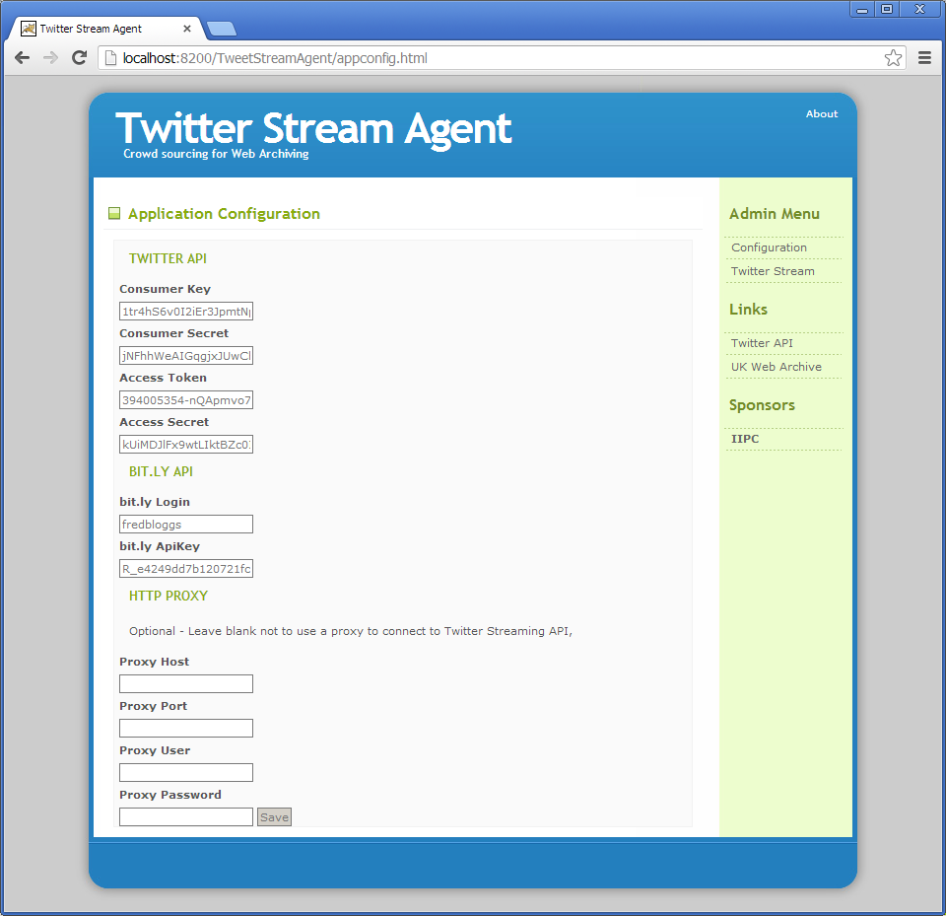

The configuration of TwitterVane is divided into three parts:

TWITTER API
Access to the Tweet stream is configured by four items that are generated by registering with the Twitter developer’s site.

Consumer Key, Consumer Secret, Access Token, Access Secret
The consumer API key, consumer secret, access token and access secret define the credentials needed to access the Tweet stream and define the way in which the account can interact with the application (eg: permission level).
These keys can be generated by following the instructions here:

https://dev.twitter.com/discussions/631

BITLY API
To expand shortened URLs, the TweetAnalyser component needs access to the Bitly expander service.

Bitly Login, Bitly API Key
The Bitly Login and Bitly API Key provide the user account and access token needed to submit requests to the Bitly API. Details on how to register and generate the key can be found here:

http://dev.bitly.com/authentication.html

HTTP PROXY
Http proxy authentication is only required when TwitterVane is situated behind a firewall (eg: on a development PC). The usual method to configure HTTP Proxy authentication consists of specifying HTTP proxy credentials as Java system parameters within the application server startup configuration.

Below is an example of the HTTP proxy configuration for a development Tomcat 6 server that is located behind a firewall:

-Dhttp.proxyUser=fredbloggs
-Dhttp.proxyPassword=testpassword

The above assumes that the system is already configured to route external requests via a proxy.

This configuration should only be applied to the application server that is running the TweetStreamAgent component. The remaining components do not require any proxy configuration.

